Accessing Facebook Ads Console

- Log into the Meta Business Suite using credentials associated with personal FB account- https://business.facebook.com/latest/home?business_id=379220090205156&asset_id=89153518368
- Select Floating Luxuries account from dropdown box in top left of page.

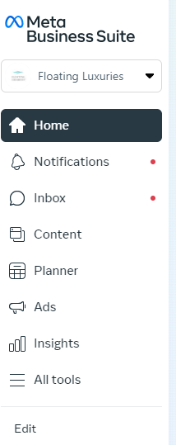

- Click on “All tools” option from lefthand navigation. Then select the “Ads Manager” from the available options.

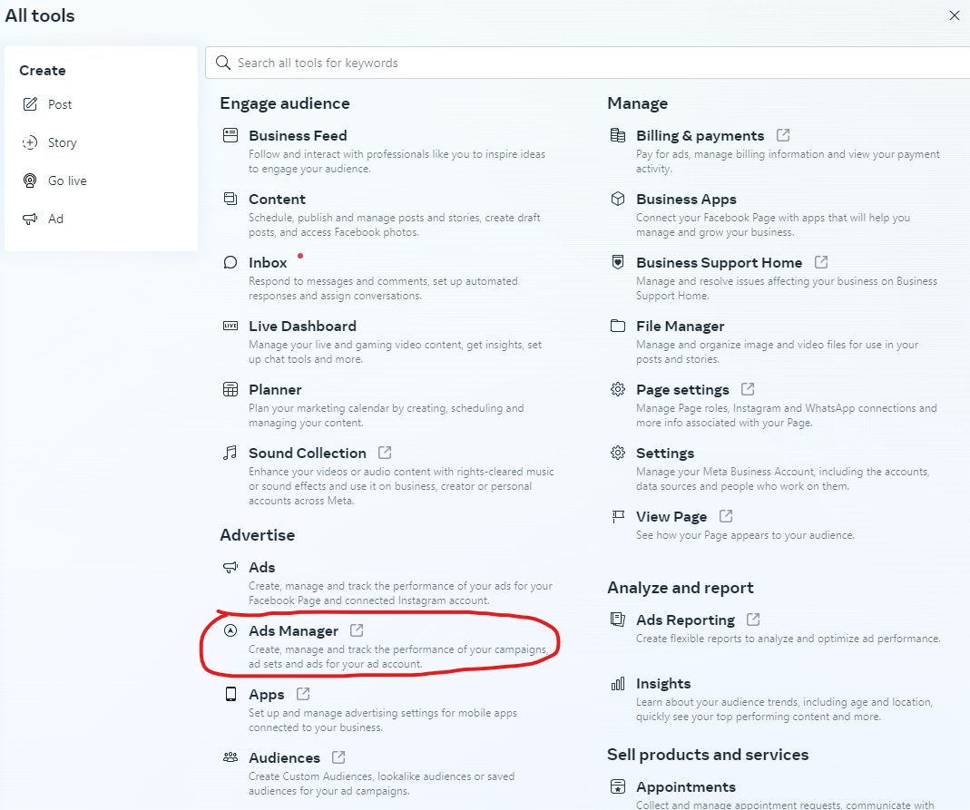

- The Ad Campaigns dashboard will then open in a separate tab and you can view all active (as well as inactive) campaigns. Make sure the Advantus Corp Ad Account is selected in the dropdown in the top left.

