Freight Claims
Freight claims are filed primarily when a shipment from the carrier is damaged, a shortage, or lost.
Customer Service or Accounts Receivable will process CREDIT MEMOS that need to be filed each month.
- Navigate to the Credit Memos – File Freight Claim: Results saved search in NetSuite: https://5050497.app.netsuite.com/app/common/search/searchresults.nl?searchid=6855
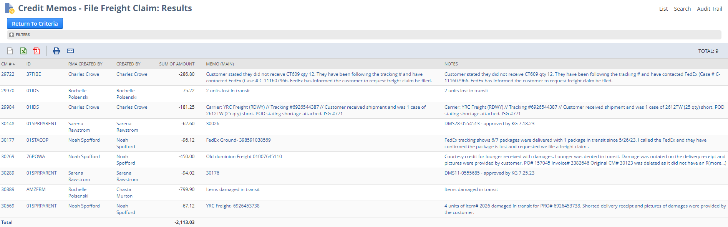

- Filter the search for the appropriate month.

- Click on the CM# to view the summary of information needed to file the freight claim.
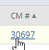

- Click View to obtain See the detail of the Credit Memo.
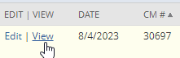

- Click on the Communication subtab to gather documentation related to the claim.
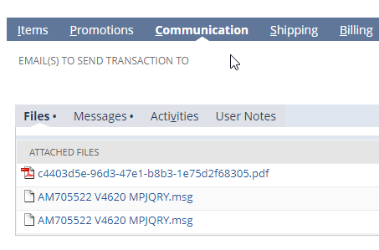
- Additional order information can be viewed by accessing the Return Authorization

- Then clicking on the Sales Order


- File the Freight Claim as outlined by the carrier instructions.

