Essendant Shipping Violation Disputes
- Essendant will send a Non-Compliance Notice via email to compliance@advantus.com for violations of their Packaging, Labeling and Shipping Requirements.

- To obtain photos of the outgoing shipment and submit a dispute:

- Log in to NS and search for the PO indicated on the violation notice.
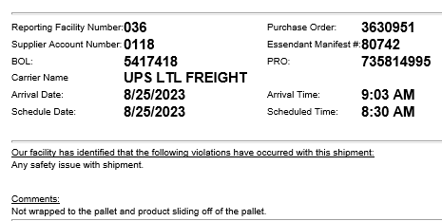

- Navigate to the Sales Order where the violation occurred.
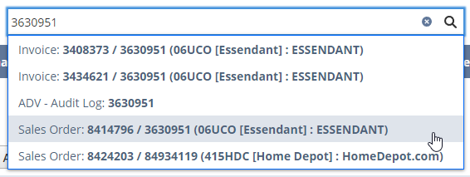

- Click on Related Records.
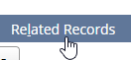

- Click on the Shipment number.

- Click on License Plates & EDI.
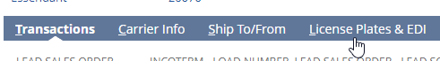

- Scroll down and click on License Plates, Parent LPs.
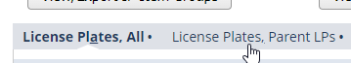

- Click on the pallet License Plate.
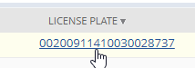
- Scroll down to Files.
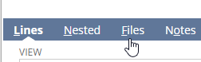

- Click on the Image name or View to view the photo, or download to send the picture via email.
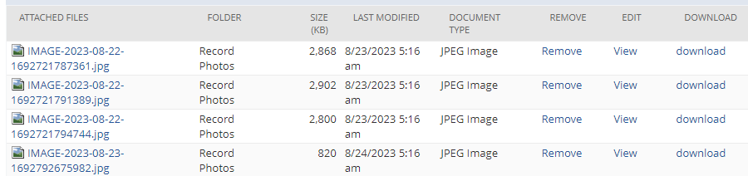

- Send a reply to SupplierPerformance@essendant.com asking them to remove the violation.

- Log the fine as Disputed until you receive a response.
- Essendant will respond to the email as Removed or Valid.
- Update the fine record appropriately.

