Amazon Fine Upload Process
- Amazon will send a summary email with a spreadsheet of all weekly fines to compliance@advantus.com. One email per vendor number.
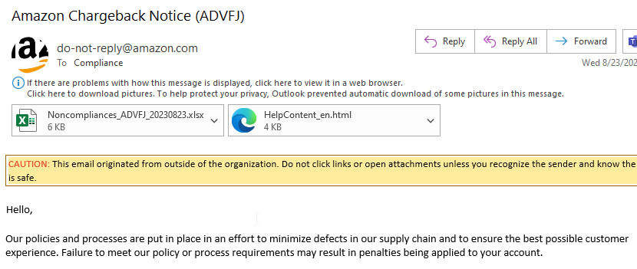

- Navigate to the ComplianceFineImportTemplate-FINAL.xlsx spreadsheet. ComplianceFineImportTemplate-FINAL.xlsx and create a copy with today’s date. Ex. ComplianceFineImportTEmplate-08.28.23.

- Complete the following Mandatory fields on the template:
- Debit memo # - This is the Issue ID on the Amazon Chargeback Excel spreadsheet.
- Amount of Debit Memo
- Purchase Order #
- Vendor Code
- Reason for Debit
- Date of Debit Notification
- Status – drop down box
- Fine Responsibility – drop-down box that mirrors the same drop-down box in NS.
- Violation Type – drop-down box that mirrors the same drop-down box in NS.
- Amount Approved/Amount Disputed
- Approved Date
- Cost of Business – if the fine is due to Cost of Business then use the drop-down box to select Yes.

- Guide to most common fines:
Reason for Fine | Fine Responsibility | Violation Type | Fine Status
PO On-Tiem Accuracy | Supply Chain | Fill Rate | Approved
Carton Content Accuracy | IT | ASN | Approved
No Carton/Pkg Content label | Shipping | Label Missing | Approved
Ship in Own Container | Cost of Business | Package | Approved
Prep – Bagging | Cost of Business | Package | Approved
Prep – External Bubble Wrapping | Cost of Business | Package | Approved
Prep – Barcode Labeling | Cost of Business | Package | Approved
Oversized Carton | Cost of Business | Package | Approved
Prep – Set Creation | Cost of Business | Package | Approved
ASN Accuracy | EDI | ASN | Researching

- Save the file as both an .xlsx and a .csv file in the following folder: Amazon Completed Uploads. The .csv file will be used to import.

- Copy the .csv file and paste it, or drag and drop it, into the Drop folder on the S drive: NetSuite Compliance Fine Uploads
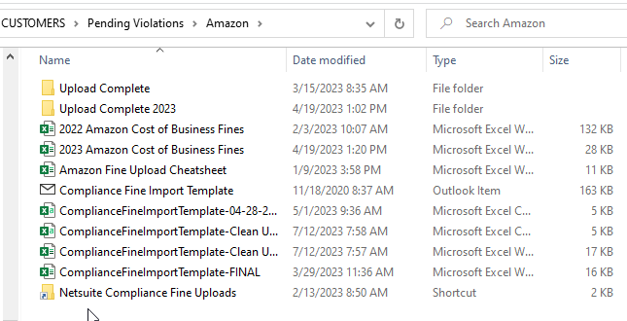

- Email notification will be provided in the Compliance inbox on the status of the upload.
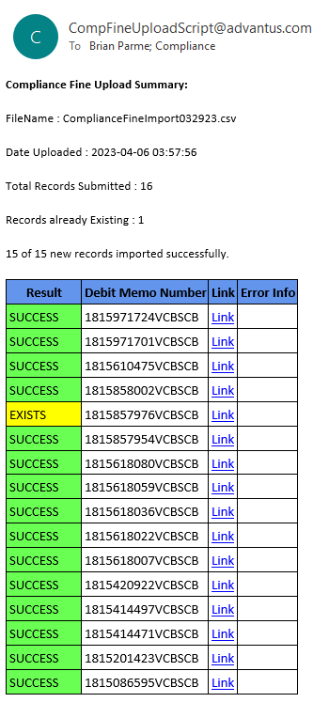
- Any records that are not successful can be edited on the fine record or resubmitted using the process above.

