Tim Holtz Closeout E-Blasts

- Every month, the craft and hobby Business manager will send an updated Tim Holtz Closeout list.
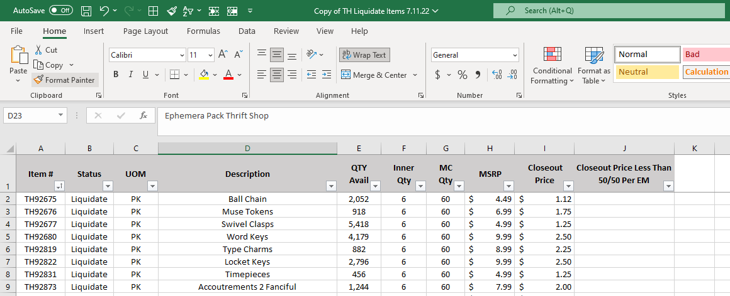
- Save this list to S:\Sales & Marketing\Craft & Hobby\ORDER FORMS\Closeouts and create a new folder for the month.
- Using the previous month’s Order Form and Details spreadsheet, update with any items that need to be removed/added and save new copies in new folder for the month. The business manager will specify the items that need to be added or removed.
- When adding or removing items, make sure to add/remove the item/s to BOTH the order form and details spreadsheet. 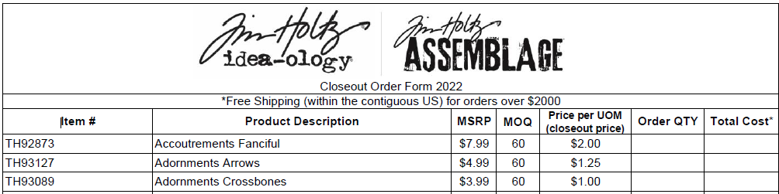
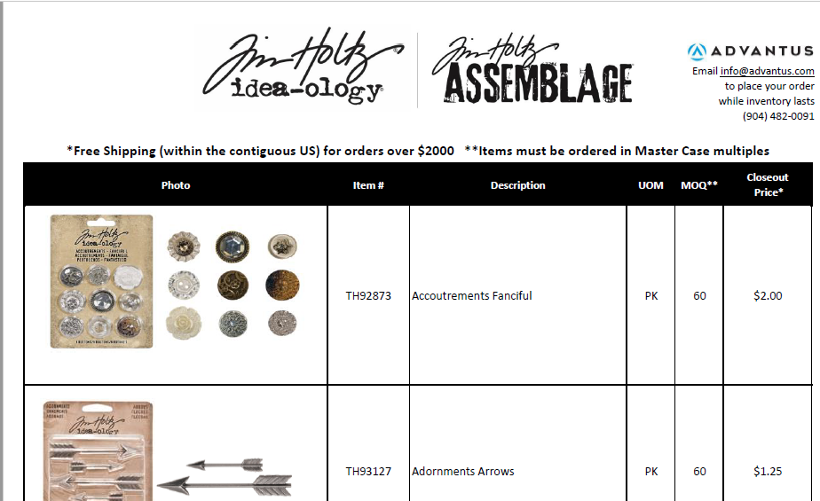
- Save the spreadsheets to S:\Sales & Marketing\Craft & Hobby\ORDER FORMS\Closeouts in their associated folder for that month.
- Log in to Dropbox and locate the ‘TH EBLAST’ folder
- Replace the old order form and details spreadsheet with the new ones that were created by dragging and dropping the files here.
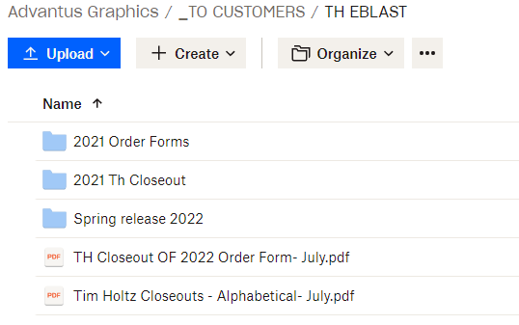
- Log in to campaign monitor.
- Find last month’s Tim Holtz Closeout campaign and press “copy”
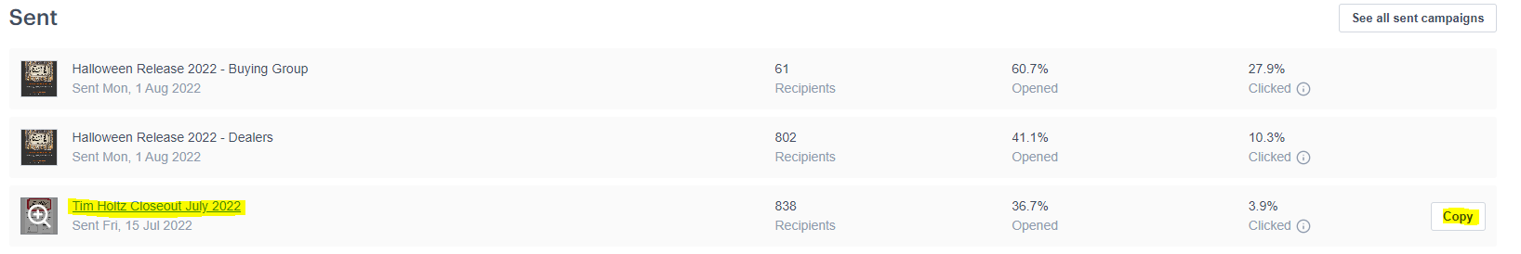
- Campaign Monitor will create a draft of this campaign which can be edited and updated.
- Review the campaign
- Since the Dropbox links do not change, the links can be left alone.
- Rename the Eblast to the current month the information is distributed.
- In the “To” section, select the following recipients
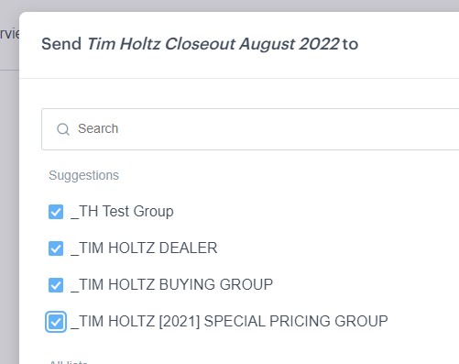
- Click “Prepare to send” and schedule the distribution for the 15th of that month at 9 AM.
- Confirm Payment and schedule to send.

