**Submitting price increases in Amazon Vendor Central**

1. Log into Amazon Vendor Central portal
2. At the top of the page, hover over “Items”
3. Select **“Edit Item Costs”** from the dropdown 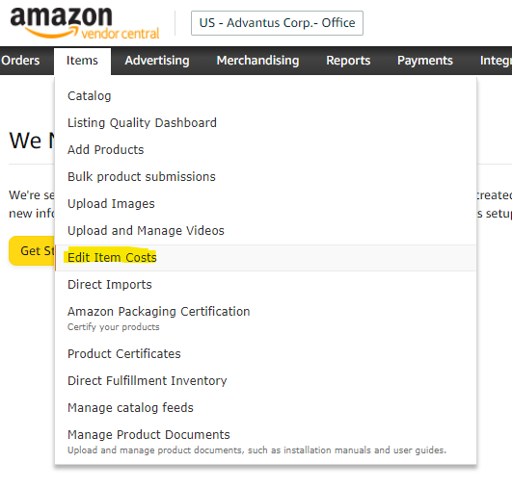
4. List the ASINs in text box that will be included in the price increase and click the “Download Costs” button 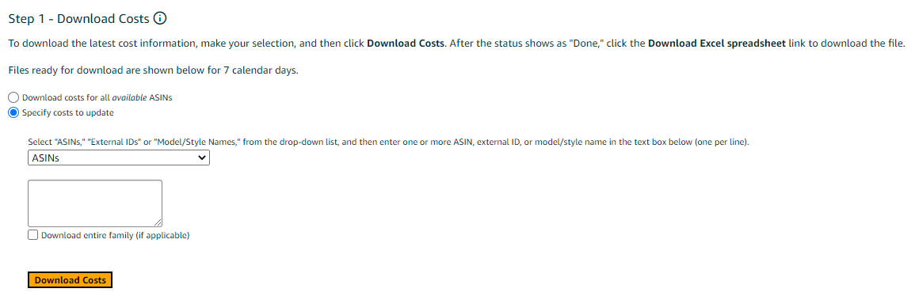
5. Complete all required fields in cost change spreadsheet and upload in the “Upload Costs” section. Note that several of the required fields are related to cost change justification. 