Inspectorio (for Target Audits) – Academy Training

[https://rise.inspectorio.com/auth/login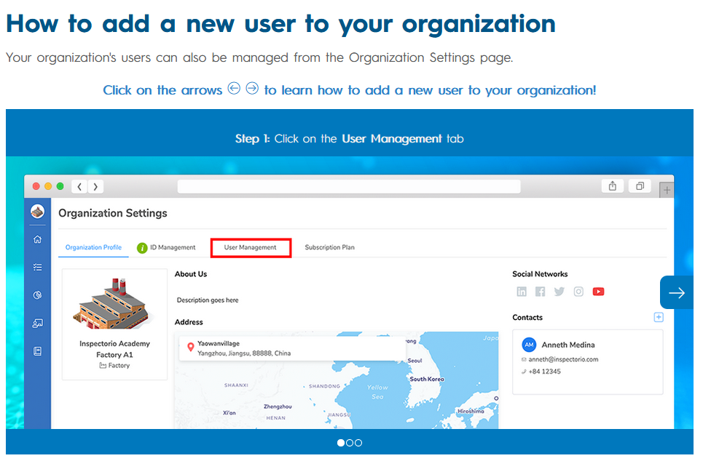](https://rise.inspectorio.com/auth/login#) 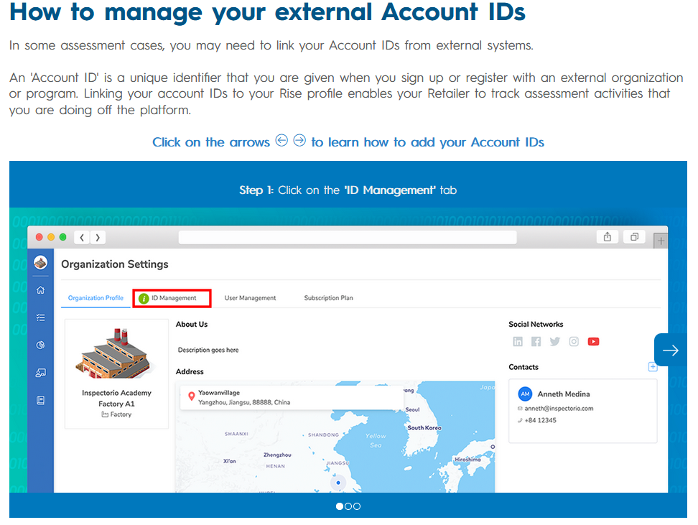

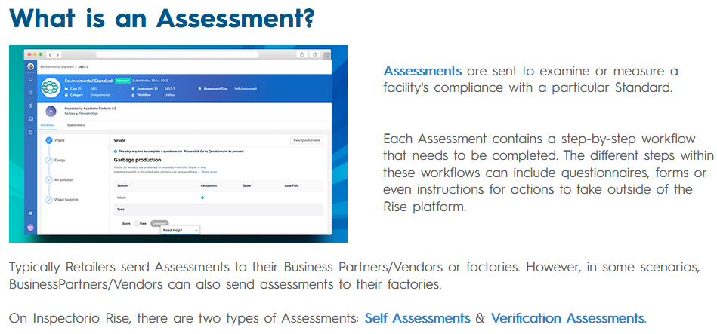

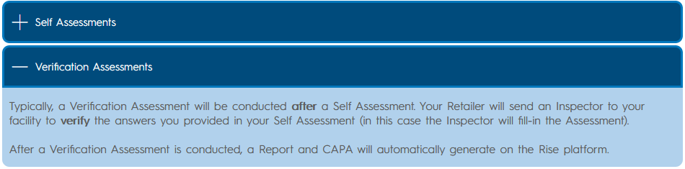

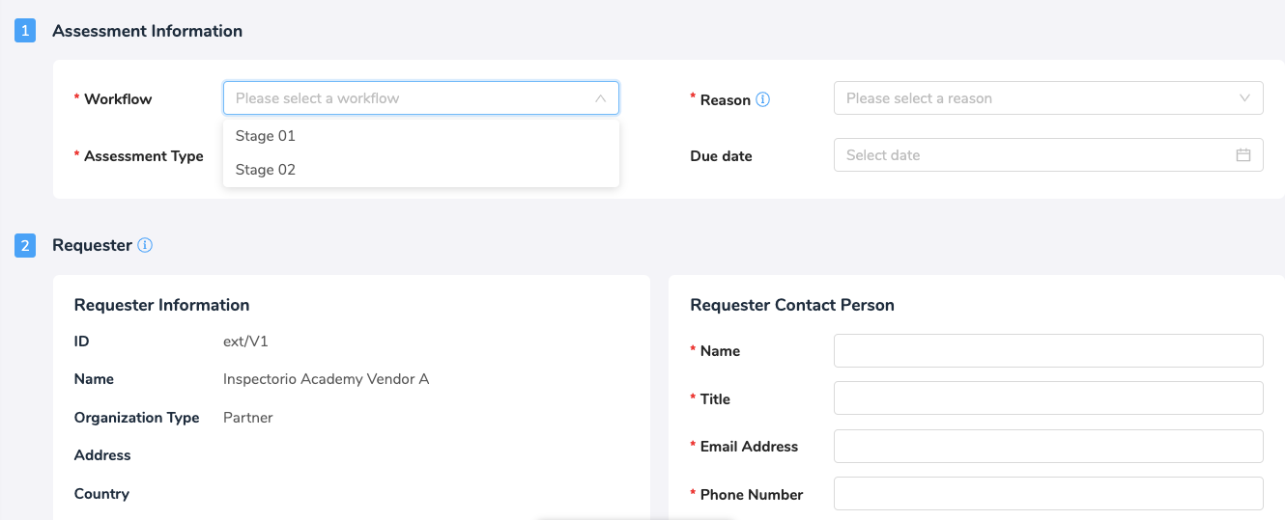

Requestor will be Advantus (for new Assessments sent to factories to complete)

Requestee and the Executor will be the factory contact and factory location where the Assessment will be done

* When Advantus is completing an Assessment for a factory Advantus is then the Requestor and Executor but the factory (Requestee) will still need to respond to the CAPA. Advantus can only comment on the CAPA

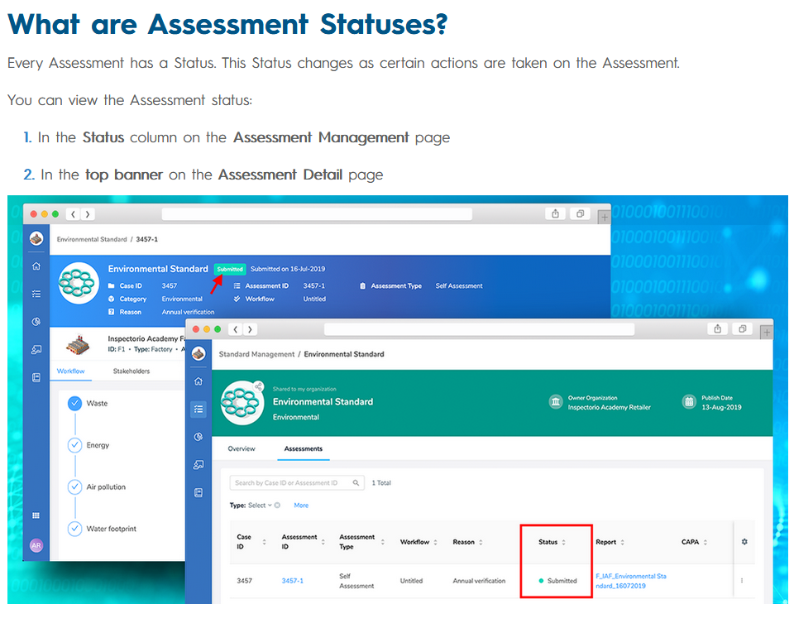

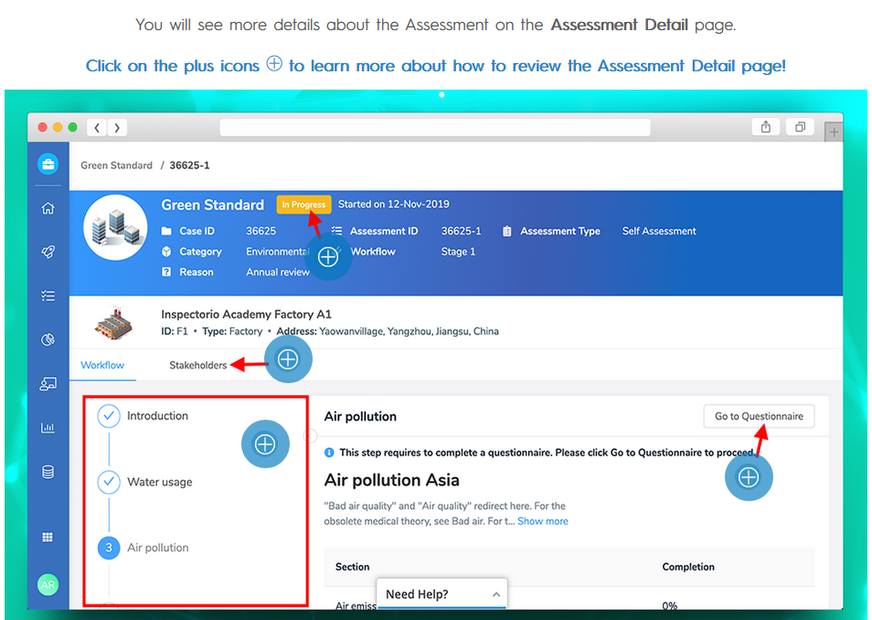

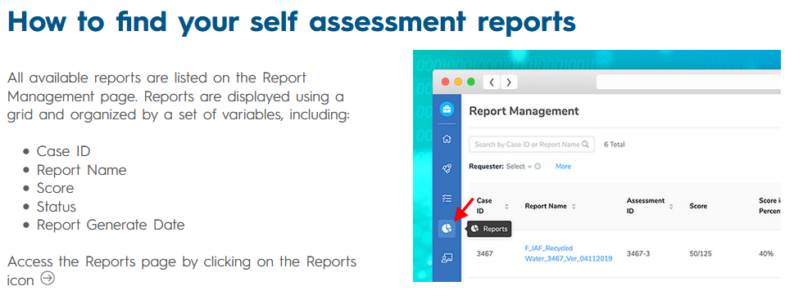

Review completed Assessments and CAPA on Report. Advantus must review “Areas to Improve” in CAPA.

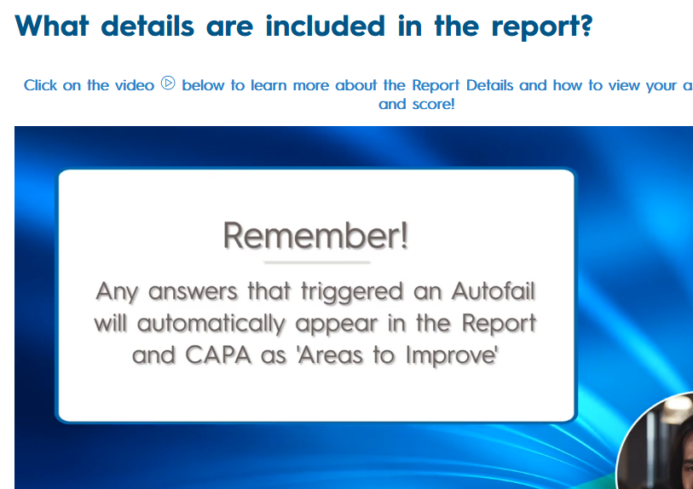

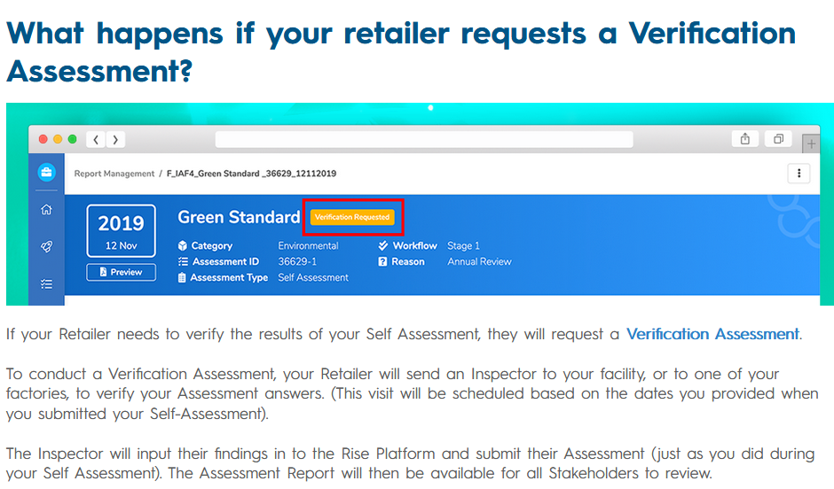

**After a Verification Assessment is submitted, a new report and CAPA are automatically generated on the platform.**

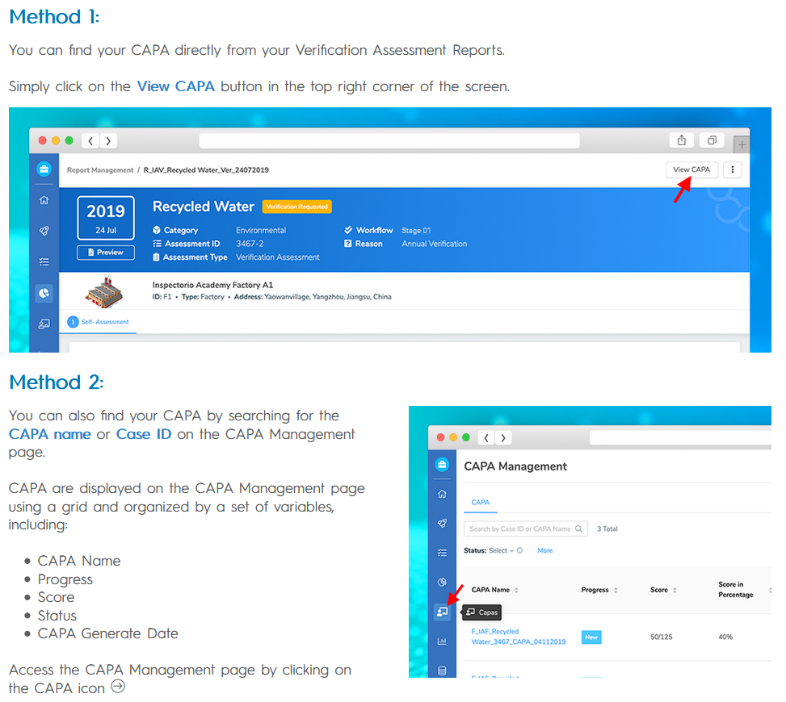

In scenarios where you are **NOT** the Requestee, you will **NOT need to fill-in the CAPA** (this is the factory's responsibility). However, in some cases you may need to **leave a comment** on section of the CAPA.

**How to view Case History**

You can review any actions that were taken on the CAPA (and through-out the entire Assessment Case) by viewing the Case History.